**Exercise 15.1: Loading HTML with Ajax**

1. When clicking in the button request the page data to the server and produce the following output using **Ajax**.

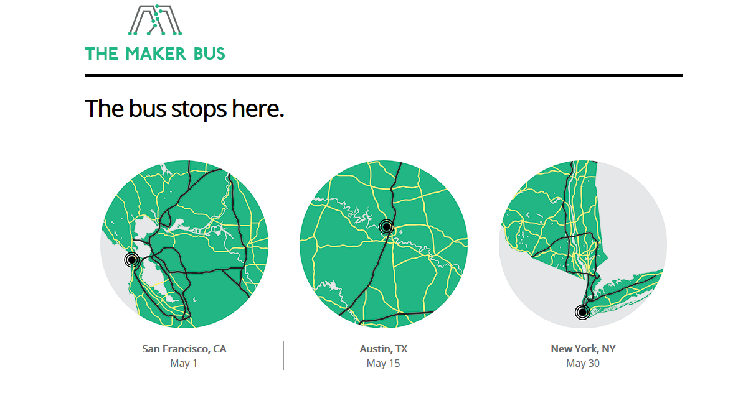

The server response is type **text/HTML**, use the following html:

<div class="event">

<img src="img/map-ca.png" alt="Map of California" />

<p><b>San Francisco, CA</b><br>

May 1</p>

</div>

<div class="event">

<img src="img/map-tx.png" alt="Map of Texas" />

<p><b>Austin, TX</b><br>

May 15</p>

</div>

<div class="event">

<img src="img/map-ny.png" alt="Map of New York" />

<p><b>New York, NY</b><br>

May 30</p>

</div>